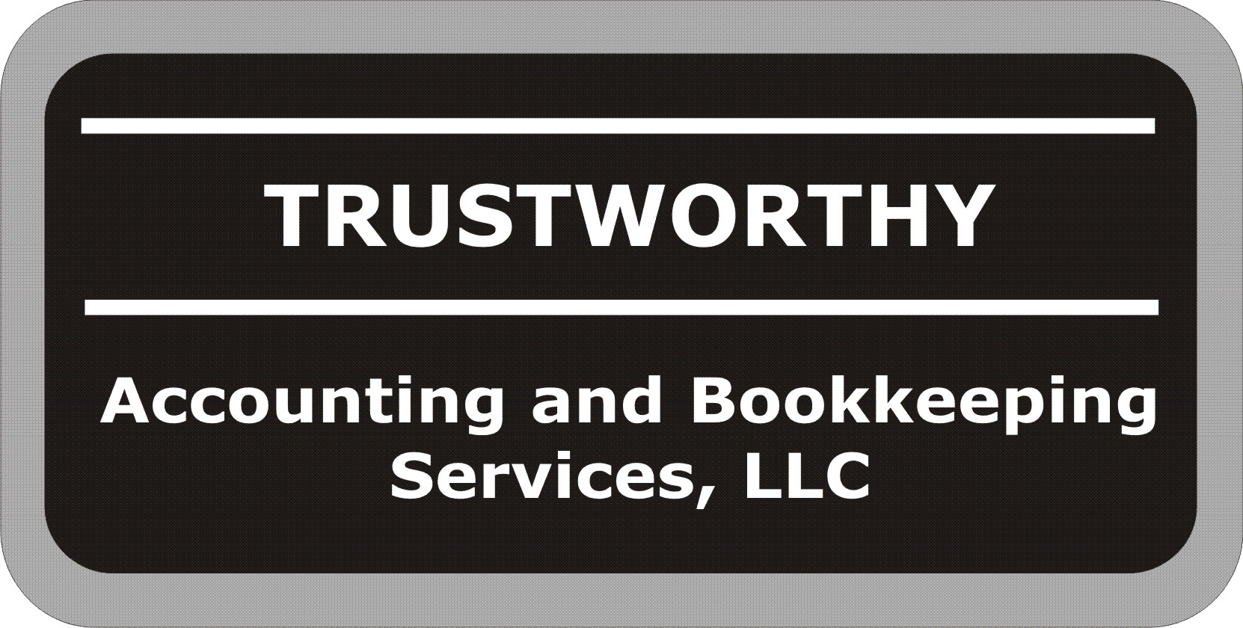
Personal Tax Organizer

Taxpayer Information
First Name |  | MI |  |  |  | Last Name |  |  |  |  |  | SS#
Address 1
Address 2
City |  |  | State |  |  |  |  |  | Zip Code
Home Phone |  |  | Cell Phone |  |  |  |  |  |  | Fax Number
Date Of Birth |  |  | Occupation
Email Address
Spouse Information
First Name |  | MI |  |  |  | Last Name |  |  |  |  |  | SS#
Address 1
Address 2
City |  |  | State |  |  |  |  |  | Zip Code
Home Phone |  |  |  |  | Cell Phone
Date Of Birth |  |  | Occupation
Email Address

Dependents
List All Persons Who Lived In Your Home or Living Outside Your Home That You Provided Over 50% of Support During Year
Name | Date of Birth | SS# | Relationship | Months Lived With You During Year | Did You Provide More Than 50% of Support
 |  |  |  |  | Yes No
 |  |  |  |  | Yes No
 |  |  |  |  | Yes No
 |  |  |  |  | Yes No
 |  |  |  |  | Yes No

Attach All W-2 Forms and All 1099 Forms and Any Other Verifications of Income
Filing Status
Single
Married Filing Jointly
Married Filing Separately
Head of Household
Qualifying Widow w/Dep Child

Income | Amount
Taxpayer Wages From Job
Spouse Wages From Job
Interest Income
Taxpayer Social Security Received
Spouse Social Security Received
Gambling, Lottery or Prize Winnings
Alimony Received
Scholarships or Grants
State Income Tax Refund (last year)
Property Sold (Residence, Land, Other)
Other Income | Amount
Unemployment
Interest Received
Sale of Assets
Gambling Winnings
Gambling Losses

Other Income (Continued) | Amount
Self Employment
Jury Duty Pay
Pensions or Annuities
Day Care Provider Income
Tips
Director or Executor Fees
Other (List Source)
Other (List Source)

Taxes Paid (Not Income Taxes) | Amount
Real Estate Taxes Paid on Your Home (Attach Bills)
Personal Property Taxes
State Taxes Paid
Other Taxes Paid

Medical Expenses (Not Reimbursed by Insurance) | Amount
Doctors Paid
Dentists Paid
Hospitals Paid
Prescriptions
Medical Insurance Premiums Paid
Glasses and Eye Exams
Hearing Aids and Batteries
Long Term Care Insurance
Laboratory and Xrays
Travel Expenses to Get Medical Care (Not Mileage)
Prosthetic Appliances
Therapy
Other (Name)
Other (Name)
Miles Driven for Medical Care (Documented)

Charitable Contributions (Cash) | Amount
Church
Payroll Deduction
Other (Name)
Other (Name)
Contributions Without Receipts
Charitable Contributions (Non-Cash) | Amount
United Way/Goodwill/Salvation Army
Other (Name)
Other (Name)
Other (Name)
Other (Name)
Miles Driven For Charitable Purposes

Interest Paid | Amount
Mortgage Interest Paid on Home
Home Equity (HELOC) Interest Paid on Home
Student Loan Interest
Other Interest Paid

Other Deductions and Credits | Amount
Union Dues
Dues-Professional Organizations
Employment Agencies
Safety Deposit Box
Job Tools and Job Supplies
Uniforms
Other (Name)
Miscellaneous | Amount
Auto Expenses (Job Use Only)
Business Meals and Entertainment
Dues and Subscriptions (Trade Journals)
Educator Expenses
Employment Agency Fees
Income Tax Preparation
IRA or Keogh Plan Fees
Job Hunting Expenses
Mutual Fund Fees
Safe Deposit Box Fees
Safety Equipment
Small Tools (Estimate Life of 1 Year or Less)
Telephone (Job Use Only)
Travel (Excluding Meals and Entertainment)
Uniforms (Not General Wear)
Uniforms, Laundry and Cleaning
Vocational Supplies
Other (Name)

Adjustments to Income |  |  |  |  |  | Amount
Alimony Paid
Paid to |  |  | SS#
IRA Contributions
IRA Penalties for Early Withdrawal
Child Care Expenses |  | # of Children
Medical Savings Account Deposits

Exemptions and Deductions Information | Please Check One
Is the taxpayer or spouse legally blind? | Yes No
Were you legally married as of December 31? | Yes No
If yes, were you living with your spouse as of December 31? | Yes No
Did your spouse die within the last 2 years? | Yes No
If yes, Date of Death?
Did you receive a state income tax refund last year? | Yes No
Did you contribute money to an IRA last year? | Yes No
Can someone else claim you or your spouse as a dependent on their tax return? | Yes No
Were any children born or adopted last year? | Yes No
Are any of your dependent children who are not full time students, 19 years of age or older? | Yes No
Do you have any children with investment income? | Yes No
If yes, what was amount?

Exemptions and Deductions Information (Continued) | Please Check One
Do you or your spouse receive payments from a pension or profit sharing plan? | Yes No
Did you or your spouse receive Social Security or disability payments during the tax year? | Yes No
Did you or your spouse receive unemployment payments during the tax year? | Yes No
Did you or your spouse receive tip income not reported to your employer? | Yes No
Did you or your spouse pay alimony or collect alimony during the tax year? | Yes No
Did you pay for child care during the tax year that allowed you to work? | Yes No
If yes, give providers name, address and tax ID
Did you or anyone in your family attend college or vocational school during the year? | Yes No
Did you or anyone in your family pay student loan interest? | Yes No
Did you buy or sell any stocks or bonds during the tax year? | Yes No
Do you incur any casualty or theft losses during the year? | Yes No
Did you incur any moving expenses during the year? | Yes No
If yes, please provide details.
Did you own your own home during the tax year? | Yes No
Did you buy, sell, or refinance a principal residence or other real property during the tax year? | Yes No
Did you start a business during the year? | Yes No
Did you purchase rental property during the year? | Yes No
Did you acquire interests in partnerships or S Corps during the tax year? | Yes No
Did you receive Earned Income Tax Credit last year? | Yes No
Do you want to have your return filed electronically if you are eligible? | Yes No
Did you use any portion of your home exclusively for business? | Yes No
Did you add energy efficient property to your home last year? (Solar, fuel cell, etc.) | Yes No
Did you purchase a hybrid vehicle during last tax year? | Yes No
Did you give fits of more than $12,000 to one or more people during tax year? | Yes No
Did you go through bankruptcy proceedings during tax year? | Yes No
Did you receive any correspondence from the IRS or the state during the tax year? | Yes No
Did you have any additional potential deductions that were not included on this organizer? | Yes No
Do you wish to Direct Deposit any federal or state refunds? | Yes No
If yes, please provide the following and bring a copy of voided check or deposit ticket:
Direct Deposit to: Checking Savings Routing Number Account Number
Did You Bring A Copy of Last Year’s Tax Return? | Yes No

Investments Sold
Stocks, Bonds, Mutual Funds, Gold, Silver, Partnership Interests –Attach 1099-B and Confirmations
Investment | Date Acquired/Sold |  | Cost | Sale Price

Business Auto and Mileage | Please Check One
Do you have written records? | Yes No
Did you sell or trade in a car used for business? (If yes, attach a copy of purchase agreement) | Yes No
Make and Year of Vehicle
Date Purchased
Total Miles (Personal and Business)
Business Miles (Not to and from work)
Round Trip Commuting Distance (to and from work)
 | Amount
Gas, Oil, Lubrication
Batteries, Tires
Repa
Repairs, Wash
Insurance
Interest
Lease Payments
Garage Rent

Business Auto and Mileage (Continued)
If you are not reimbursed for exact amount, give total expenses | Amount
Airfare, Train, etc.
Lodging
Meals (number of days )
Taxi, Car Rental
Other Travel Expenses
Reimbursement Received

Questions, Comments and Other Information

To the best of my knowledge, the enclosed information is correct and includes all income, deductions, and other information necessary for the preparation of this year’s income tax returns for which I have adequate records and I understand that this will be the sole basis for Trustworthy completing my tax returns.

_________________________________________ __________________ ___________________________________________ ______________________
Taxpayer Date Spouse Date

